REST API

User (Admin login ):

ADD USEADD

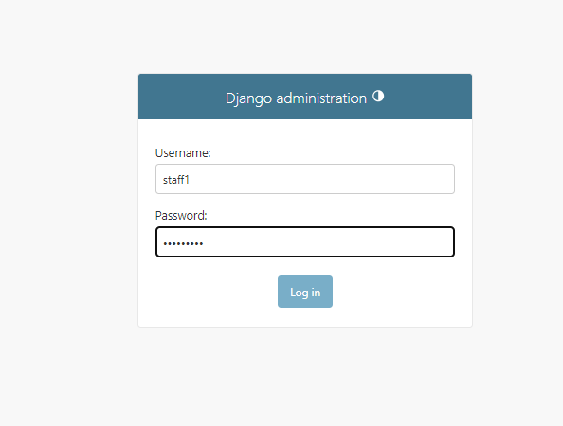

ADD USER

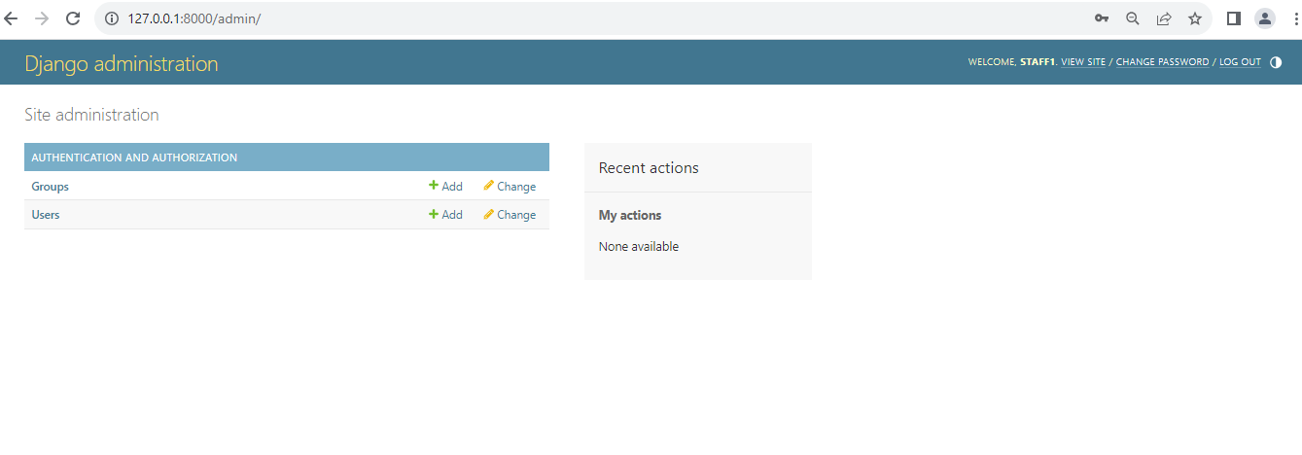

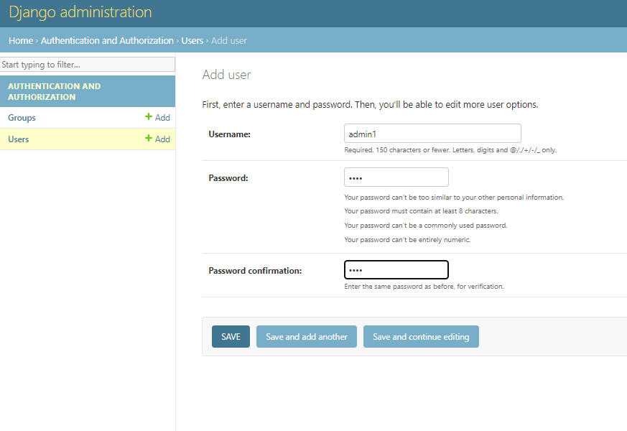

ADD personal Information and Save:

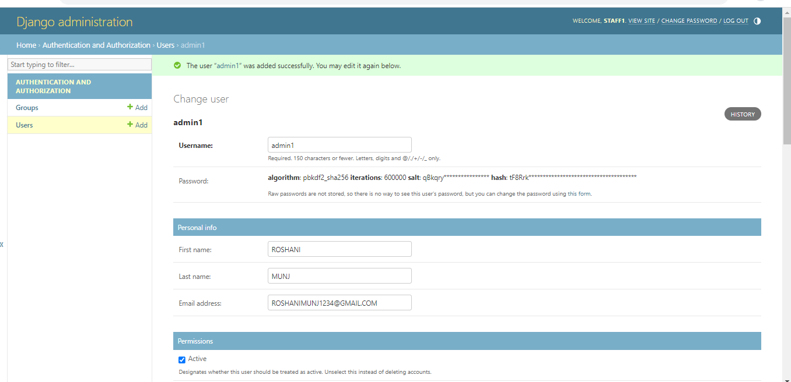

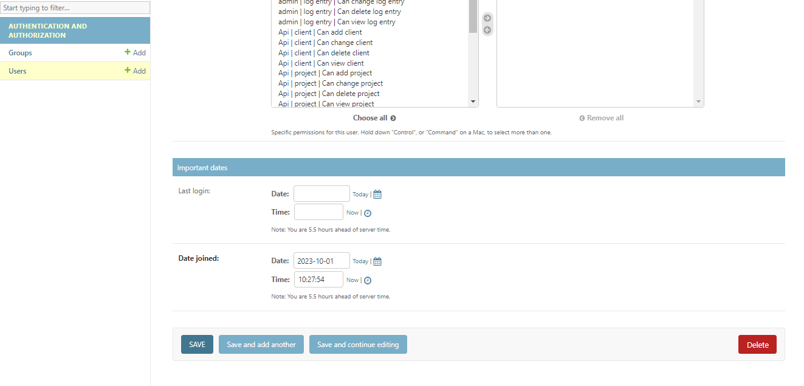

Show all the user :

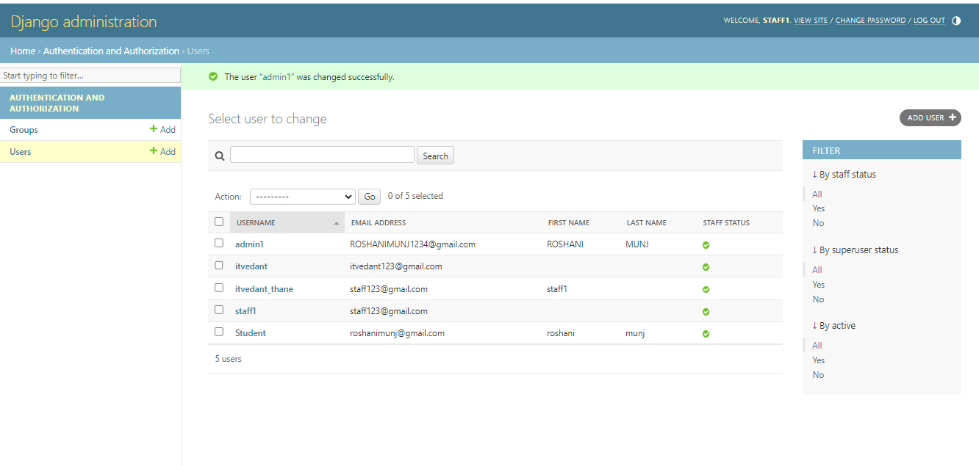

Delete the user :

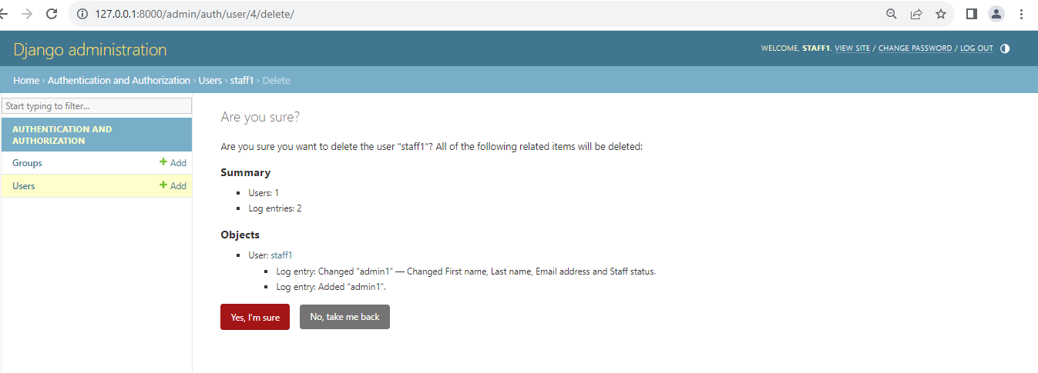

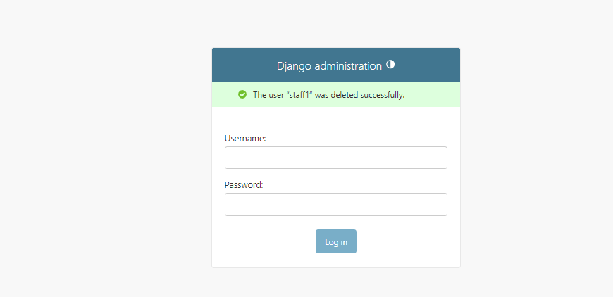

* **List of all clients**

**GET /clients/**

* Retrieve info of a client along with projects assigned to its users

**GET /clients/:id**

Sourcecode:

def get_client(request):

    c=client.objects.all()

    print(c)

   # res={'sucess':"response from get_client"}

    context = {}

    i=0

    for x in c:

        context[i]={

            'id':x.id,

            'client_name':x.client_name,

            'created_at':x.created_at,

            'created_by':x.uid.first_name

        }

        i+=1

    print(context)

    json_data=json.dumps(context,default=str)

    return HttpResponse(json_data,content_type="application/json")

**output:**

{

"0": {

"id": 1,

"client_name": "comapany 3",

"created_at": "2023-09-29 13:22:19.009394+00:00",

"created_by": ""

},

"1": {

"id": 2,

"client_name": "comapany1",

"created_at": "2023-09-29 13:22:19.009394+00:00",

"created_by": "staff1"

},

"2": {

"id": 3,

"client_name": "comapany2",

"created_at": "2023-09-29 13:22:19.009394+00:00",

"created_by": "staff1"

}

}

* **Create a new client**

**POST /clients/**

@csrf_exempt

def create_client(request):

    print(request.method)

    print("in create client")

    print(request.POST)

    cname=request.POST['cname']

    user_id=request.POST['user_id']

    u=User.objects.filter(id=user_id)

    print(u)

    print(u[0])

    c=client.objects.create(client_name=cname,uid=u[0])

    c.save()

    res={'sucess':"create client sucessfully"}

    json_data=json.dumps(res)

    return HttpResponse(json_data,content_type="application/json")

**output:**

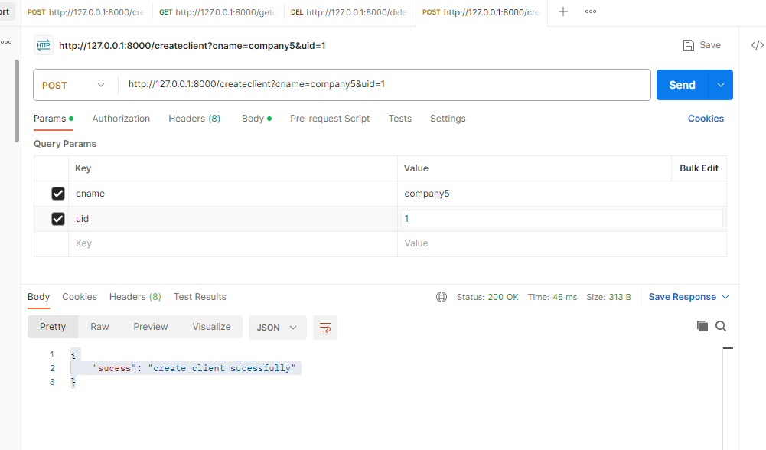

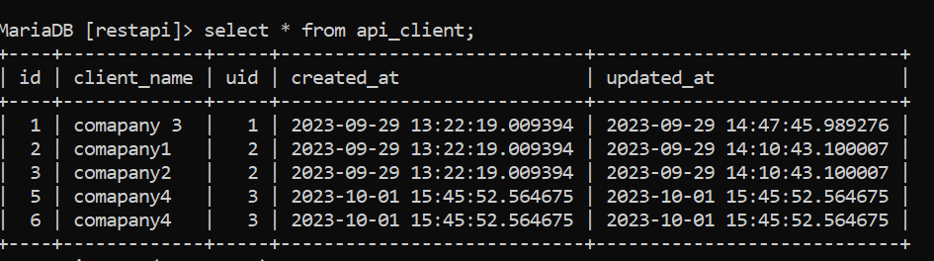

* **Update info of a client**

**PUT-PATCH /clients/:id**

@csrf_exempt

def update_client(request,rid):

    print("in update client")

    print(request.method)

   # print(request.POST)

    print(request.body)

    d=json.loads(request.body)

    print(d)

    #print(type(d))

    #print("record id:",rid)

    ucname=d['name']

    c=client.objects.filter(id=rid)

    print(c)

    c.update(client_name=ucname,updated_at=datetime.datetime.now())

    res={'success':"client updated successfully"}

    json_data=json.dumps(res)

    return HttpResponse(json_data,content_type="application/json")

   res={'sucess':"update client sucessfully"}

    json_data=json.dumps(res)

    return HttpResponse(json_data,content_type="application/json")

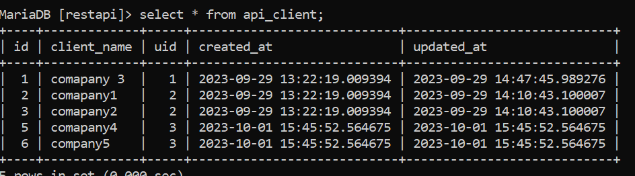

* **DELETE /clients/:id**

The response status should be 204.

@csrf_exempt

def delete_client(request,rid):

    print("in delete client")

   # c.delete(client_name=ucname,updated_at=datetime.datetime.now())

    res={'sucess':"delete client sucessfully"}

    json_data=json.dumps(request,rid)

    c=client.objects.filter(id=rid)

    c.delete()

    print(c)

    return HttpResponse(json_data,content_type="application/json")

output

